1. Bus topology diagram
BUS TOPOLOGY
PC 1
PC 2
Printer
PC 3
Main bus cable (backbone)
Terminator
Terminator
Key components: Computers, shared backbone cable, connection points, and terminators at both ends.
Real-world example: Older Ethernet networks using coaxial cable (10BASE2 or 10BASE5) used bus topology.
2. Create a star topology in Cisco Packet Tracer
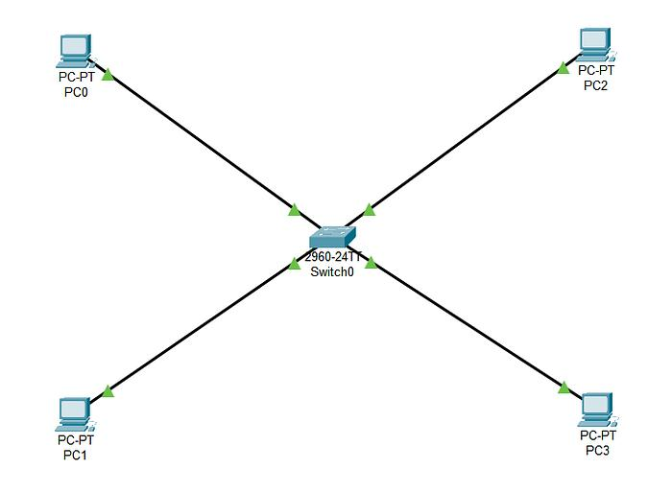
Steps:
- Open Cisco Packet Tracer.
- Add one 2960 Switch and four PC-PT devices.
- Connect each PC to the switch using Copper Straight-Through cables.
- Rename the PCs:
  - PC0 → WhatsApp
  - PC1 → Zomato
  - PC2 → Spotify
  - PC3 → Flipkart
- Connect each PC's FastEthernet0 port to a different switch port, such as Fa0/1–Fa0/4.
- Wait for the link indicators to turn green.
- Take a screenshot using Win + Shift + S.
Result: All four PCs connect to one central switch, forming a star topology.
3. Ring topology diagram
RING TOPOLOGY
Arrows show the direction of data flow.
Explanation:
In a ring topology, each device connects to two neighboring devices, forming a closed loop. Data travels from one device to the next in the direction shown by the arrows until it reaches its destination. Some ring networks use a single direction, while others support two directions.
4. Mesh vs Star topology
Topology | Advantages | Disadvantages
Mesh | 1. Multiple paths can keep communication working if a link fails. 2. Reliable and fault-tolerant. | 1. Requires more cables and connections. 2. Expensive and complex to set up.
Star | 1. Easy to install and manage. 2. Failure of one cable usually affects only one device. | 1. If the central switch fails, connected devices lose network connectivity. 2. Requires separate cable runs to the switch.
Conclusion: Star topology is common in homes, schools, and offices because it is easy to manage. Mesh topology is useful when reliability and alternative communication paths are important.

